Curriculum Vitae
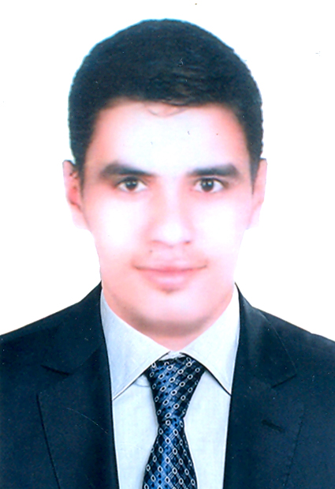

Name: Esmat Abdo Hamdan Allam

Nationality: Egyptian

Sex: Male

Date of Birth: April 23rd, 1995

Place of Birth: Assiut, Egypt

Marital Status: Single

Contact Address: Department of Pharmacology, Faculty of Pharmacy, Assiut University, Assiut, Egypt

Cell Phone Number: +201555949806

E-mail: Essmatallam8@gmail.com
Essmat.Abdo.Hamdan@pharm.aun.edu.eg

Languages: fluent in Arabic and English

Education:
- Bachelor in Pharmacy, Faculty of Pharmacy, Assiut University, Assiut, Egypt, June 2018.
- Grade: Excellent with Honors.

Academic Positions
March 2019 - | Demonstrator at Department of Pharmacology, Faculty of Pharmacy, Assiut University, Assiut, Egypt.

Computer skills:
- Microsoft office word
- Power-point
- Excel
- Access
- Internet

